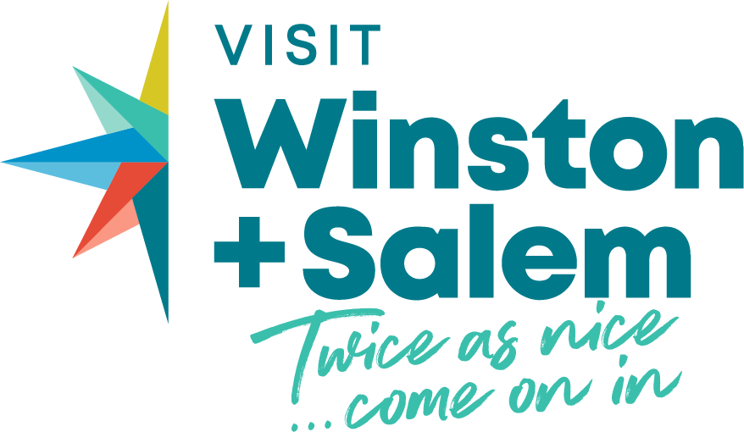

Media Contact:
Brandy Evans, Chief Marketing Officer
Visit Winston-Salem
336-529-4211 or brandy@visitwinstonsalem.com

Visit Winston-Salem Reports Record-Breaking Year
New brand campaign, major group events booked, and record web traffic highlight a year of growth
WINSTON-SALEM, NC (July 22, 2025)-Visit Winston Salem hit new records posting its most successful fiscal year - July 1, 2024-June 30, 2025 - highlighted by a new brand launch, higher hotel revenue, record website visitation and increased booked group events.
Hotel revenue jumped 10 percent year-over-year with more than 1.8 million hotel room nights sold in Forsyth County. By comparison, the state revenue was up 4 percent, according to Visit North Carolina.
“Our goal this year was to grow by leaps and bounds,” said Stephanie Pace Brown, President and CEO of Visit Winston-Salem. “The dramatic increase in tourism-related revenue tells us our strategies are working hard to enhance the reputation of Winston-Salem as a great place to visit.”
Both leisure visitation and group events have seen remarkable growth. Definite room nights associated with convention, sports and group business secured by the Visit Winston-Salem sales team are near 70,000 rooms nights (up 13 percent) with an estimated economic impact of $84 million (up 7 percent). Some major new multi-year bookings landed this year include: North Carolina EMS (2026-2030), North Carolina Local Government Information Systems Association (2025-2027), North Carolina Rural Water Association (2026-2027), and North Carolina Prince Hall Grand Chapter Order of the Eastern Star (2025-2027).
On the sports side it was a strong year for youth and collegiate sports with 41 bookings generating 15,000 room nights across a variety of sports - basketball, tennis, track and field, cycling, soccer, lacrosse, dance, field hockey, dog competitions, hockey, golf, gymnastics, motorsports, volleyball, running, and sports meetings. From a professional sports perspective The Clash, which recently announced it is coming back in 2026, and the annual Winston-Salem Open were also big winners for the community.
Additionally, the Benton Convention Center had its best year ever with $7.9 million in revenue, up 20 percent.
Grant Minnix, Director of Operations for the Benton, said the success is largely based on bookings with larger delegations who stay longer periods of time. This fiscal year, he said the convention center was booked 295 out of 365 days. He credits the reasonable price of the center and excellent hospitality for repeat and future bookings.
“It’s not just one person who makes this all go, it is the sales team at Visit Winston-Salem, the sales team at the Marriott, as well as our sales team. There is a lot to be said that this is a team effort to bring meetings and conventions here to Winston-Salem.”
Attracting leisure visitors is a focus of Visit Winston-Salem’s new marketing efforts that were launched under the new brand “Twice as nice…come on in” in September 2024. The advertising campaign generated more than 66 million impressions across a wide range of digital platforms. This led to the most website traffic in the organization’s history with over 2 million website sessions, a 125 percent increase over the previous year, and up from 200,000 just two years ago.
The marketing campaign showcases Winston-Salem as a fun, vibrant, and welcoming destination to potential visitors from Washington, D.C. to Atlanta, Georgia. The marketing mix shifted from primarily traditional print advertising to a mix of modern digital tactics with support from owned channels like social media, public relations, e-newsletters, and an enhanced website.
Tourism promotion is funded by overnight guests who stay in paid lodging. Visitors spend money with local businesses, support jobs, and generate tax revenue – all leading to greater visibility and vitality for the community.
Looking ahead, Visit Winston-Salem will build on this strong momentum by continuing to elevate the destination’s brand and reputation, driving economic growth through strategic sales and marketing initiatives, and supporting the venues, attractions and events that make the community distinct.
Seven million people visit Forsyth County annually. They spend more than a billion dollars, support 6,700 jobs and generate $72 million in state and local taxes.
Interviews can be arranged with Visit Winston-Salem President & CEO Stephanie Pace Brown or Chief Marketing Officer Brandy Evans. For more information about the destination go to, www.VisitWinstonSalem.com.

ABOUT THE ORGANIZATION
Visit Winston-Salem is a quasi-governmental entity and the official sales and marketing agency for tourism for Winston-Salem/Forsyth County. Operating under the Forsyth County Tourism Development Authority (TDA), the organization’s mission is to attract visitors for the economic benefit of Forsyth County and its citizens. They develop and implement sales and marketing initiatives that position the city as an attractive destination for leisure, meetings, conventions, groups, and sporting events.

